Self-Scheduling is now available with Virginia Gay!
This is triggered once an order for a screening mammogram has been placed. If the date is placed for a future date, MyChart respects that and you will not be allowed to choose a date earlier than the expected date. The Appointment Request will stay open as long as the order is good.
This is for screening mammograms only. Please contact your provider regarding scheduling for any other breast imaging.
Once a screening mammogram is ordered for a patient, the patient will receive a notification via text informing them of the opportunity to self-schedule the appointment.
- Patients will see the following disclaimer when choosing a time “Please note: Coverage varies by insurance company or plan. Some insurance companies limit how frequently they will cover mammogram screenings. We recommend confirming your coverage with your insurance company prior to scheduling.”

- Patients can schedule same day appointments if an appointment time is available, however, cannot schedule less than 2 hours in advance of the appointment time.
  - If the patient cancels or no shows the ticket will regenerate automatically, and the patient will answer decision tree questions again. If they reschedule, the patient will not answer the decision tree questions over again

What a patient will see in their MyChart.
MyChart Welcome page. Select “Schedule now”
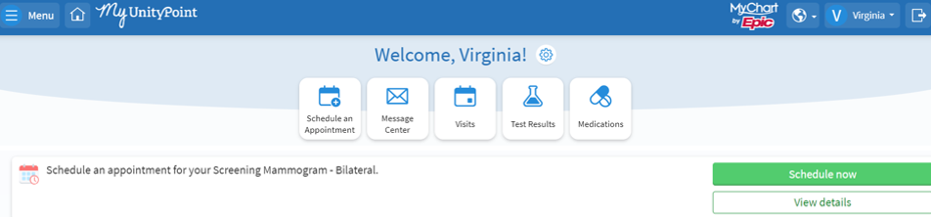

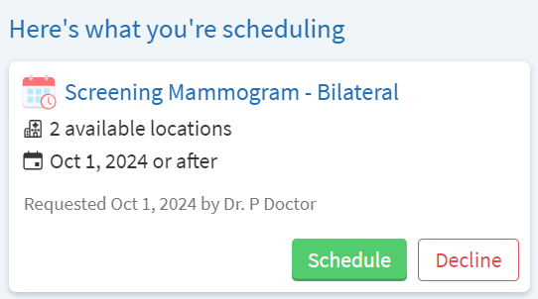
Select “Schedule”

Follow screen prompts to complete the questionnaire.
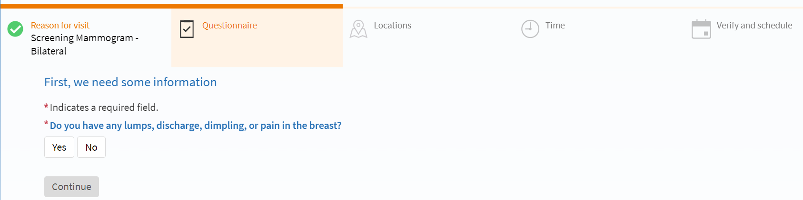

Choose location from options below. Use sidebar scroll on the right to search for Vinton. Select desired location and then continue.
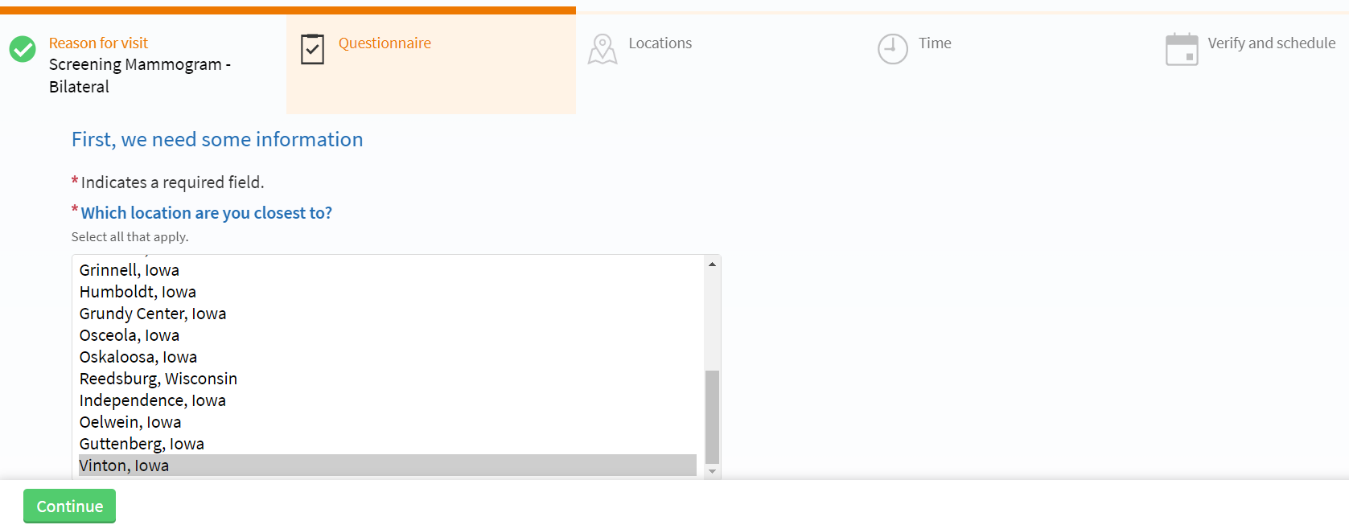

Follow prompts to complete additional questions.
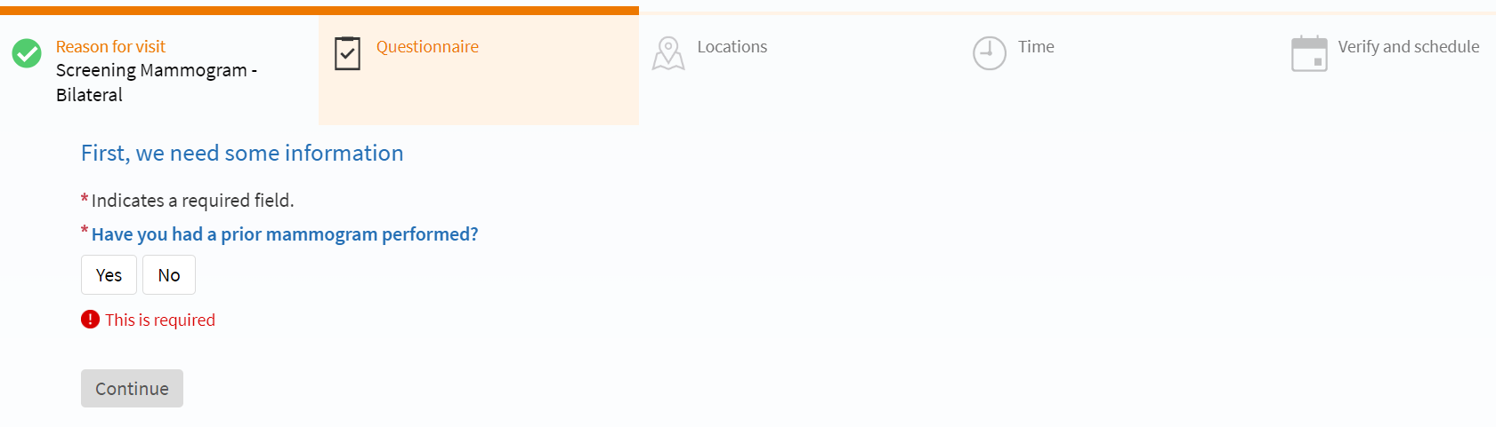
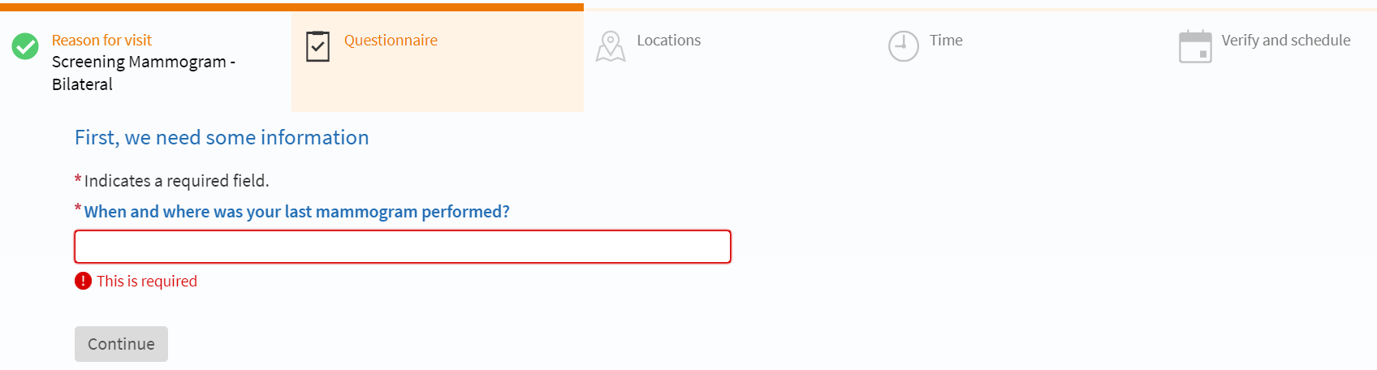

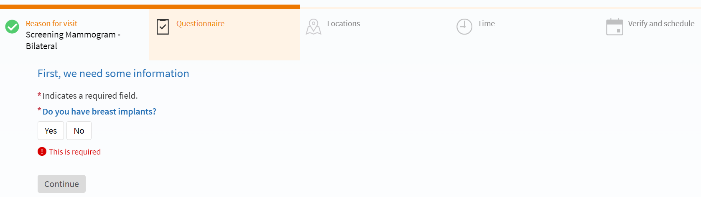
“Do you have any on body medication pumps, infusers, or sensors?” If Yes: the instructions say “you will need to remove the pump prior to imaging. If you have a sensor, schedule your procedure near the end of the sensor session. If exam is urgent or needed sooner, you will need to bring a replacement sensor with you.
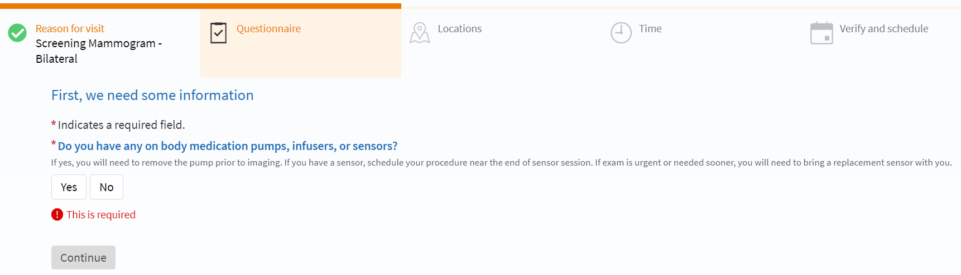

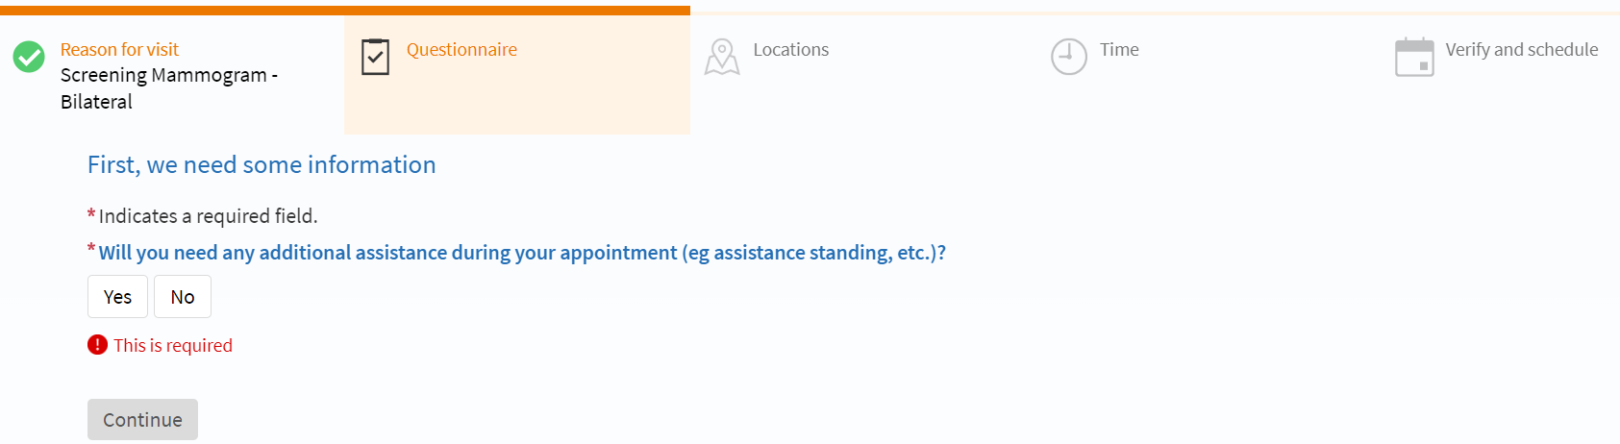

Choose a date and time from the available options.
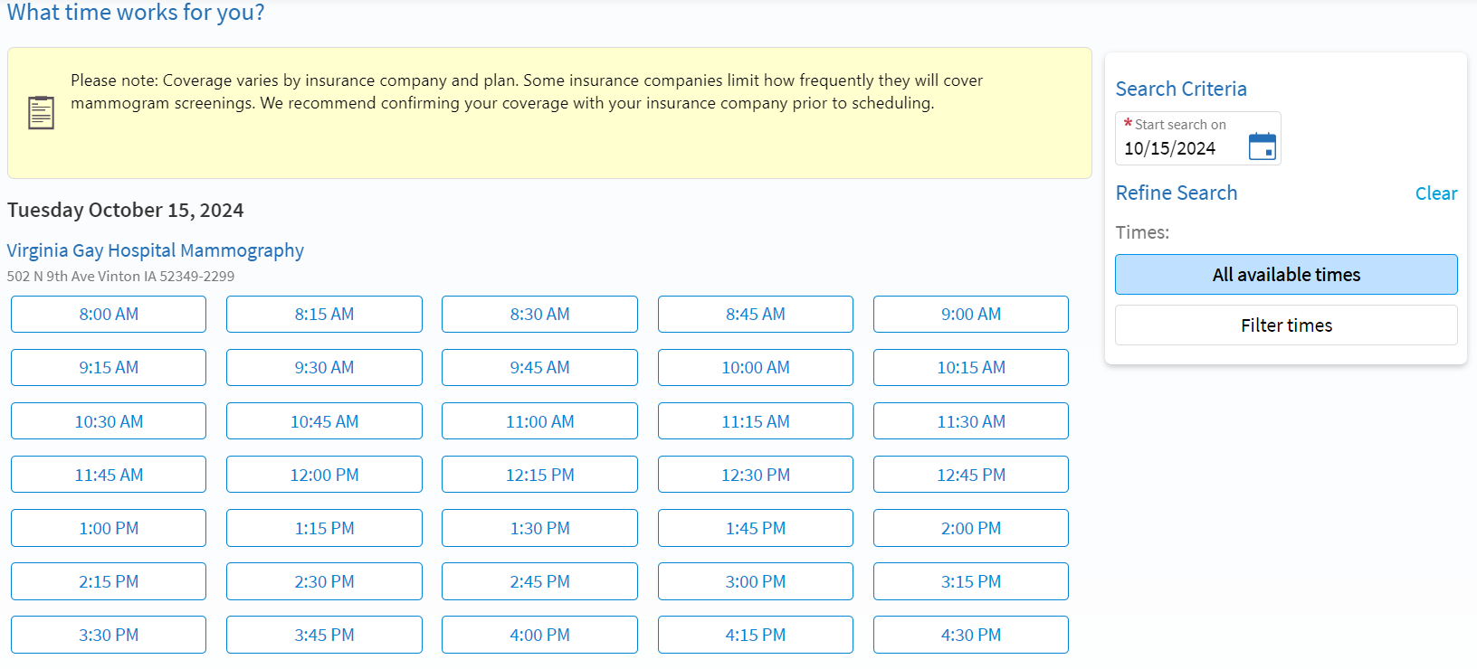
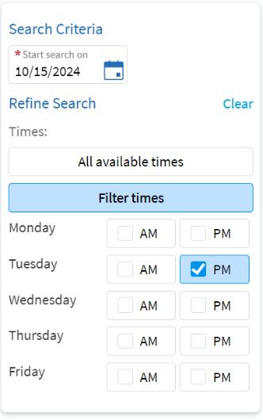
Select “Filter times” to filter day of the week and time of day.

Review appointment date, time, and location. Add comments and select “Schedule it” when finished.
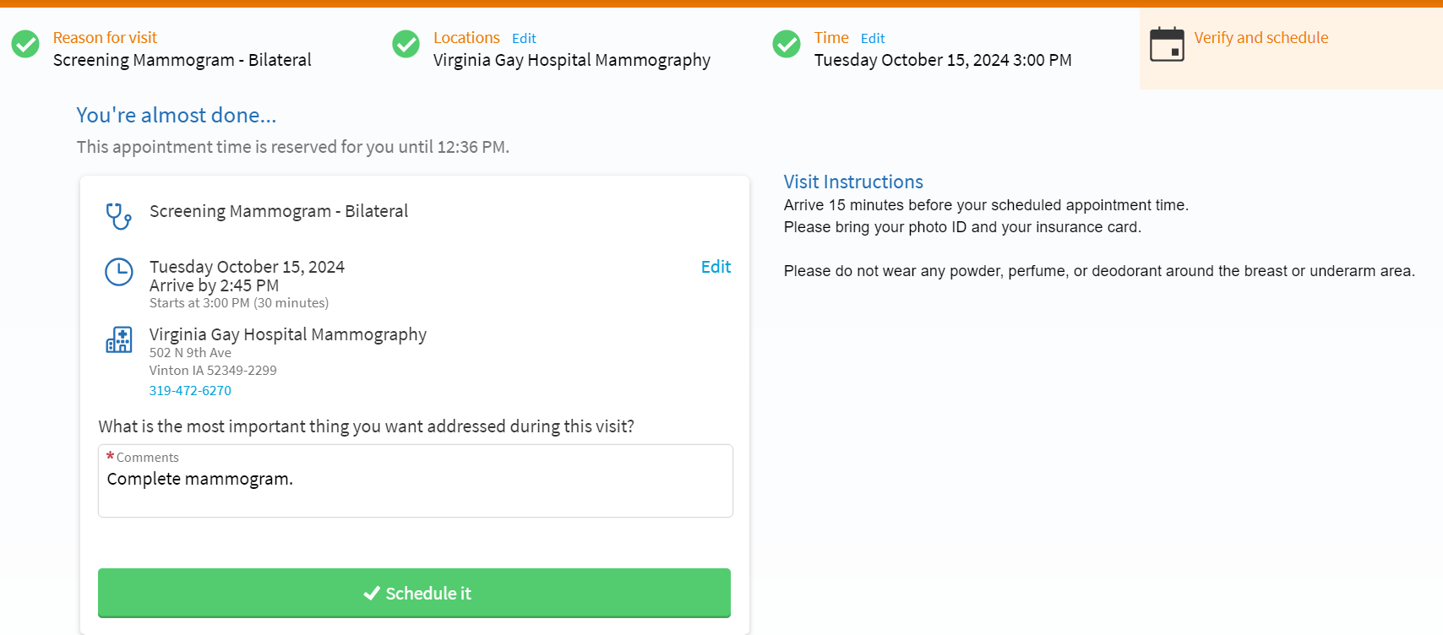
You will see that you now have a screening mammogram scheduled. Should you need to adjust your appointment, please contact hospital scheduling, 319-472-6270. 