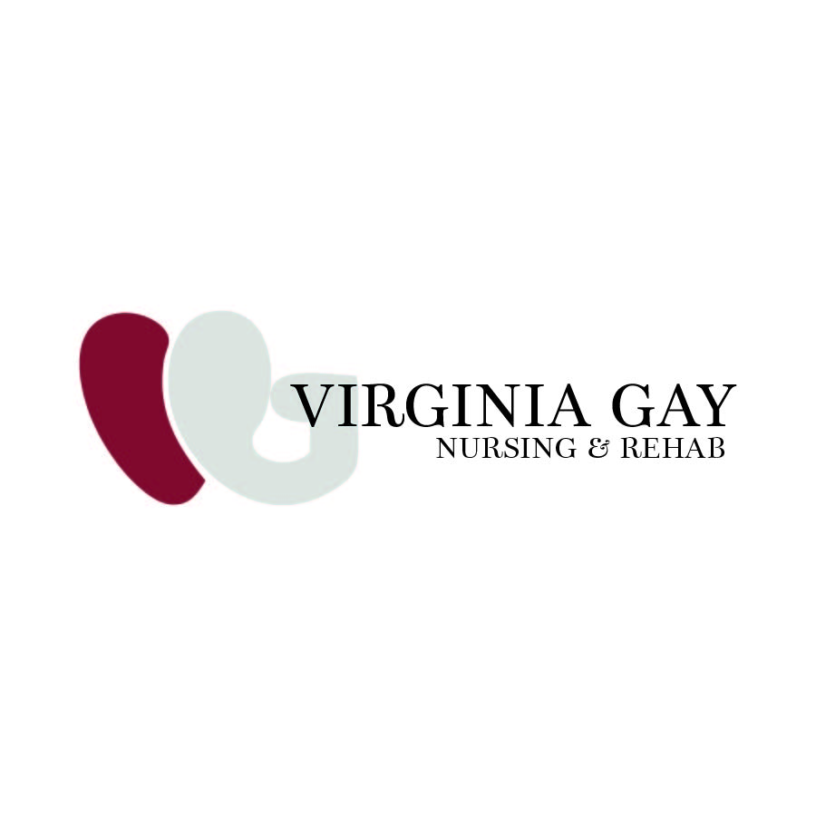

Dr. Tony & Dottie Anthony Scholarship Application
Virginia Gay Hospital Nursing & Rehab
In honor of the legacy of Dr. Sherman "Tony" Anthony and Dottie Anthony Anderson—and thanks to the generosity of the Anthony Family—a $500 scholarship will be awarded annually to a Virginia Gay Hospital Nursing & Rehab employee who is furthering their education in the healthcare field.
Eligible applicants must have completed at least six (6) months of employment at VGH Nursing & Rehab at the time of application. The recipient will be selected based on their professional aspirations, commitment to healthcare, and potential for growth.
The selection committee includes a member of the Anthony Family, the Nursing & Rehab Nurse Manager, and the Assistant Nurse Manager.
Please return the completed application to your Administrator by July 31.
The scholarship recipient will be notified by August 15, and a check will be sent directly to the business office of the college you plan to attend.

Applicant Information
Your Name: ___________________________________________
College You Plan to Attend: ___________________________________________

Application Questions
1. What inspired you to further your education in the healthcare field?

2. How do you plan to use your education to contribute to the healthcare profession upon graduation?

3. Why do you believe you should be selected for the Dr. Tony & Dottie Anthony Scholarship?

4. What qualities do you possess that will help you succeed in your chosen healthcare career?

5. List all schools or colleges you have attended since high school.
Include the year(s) attended, diploma or degree obtained, or a brief explanation if you did not graduate.
Example: 2025 – Graduated from Kirkwood Community College – Associate Degree in Nursing

