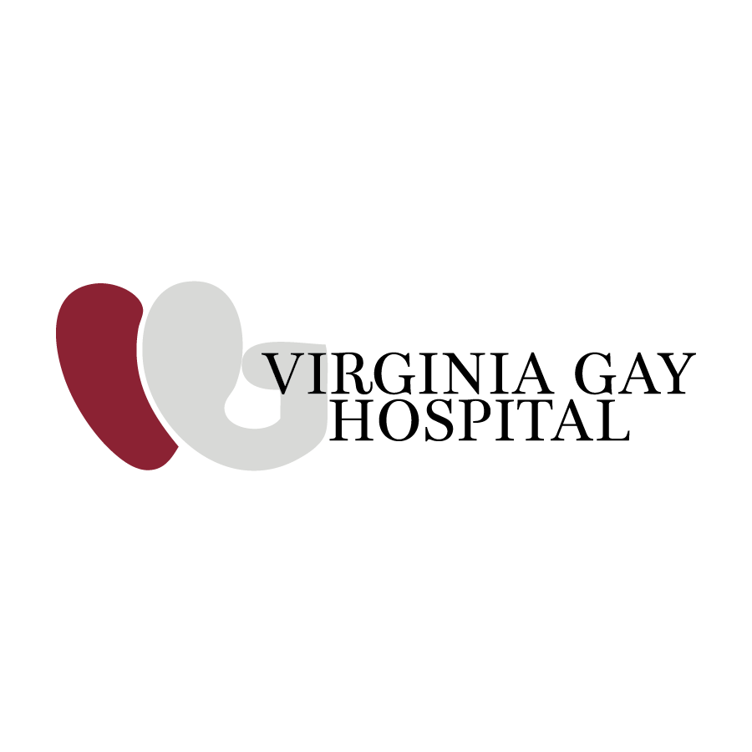
7/15/2025
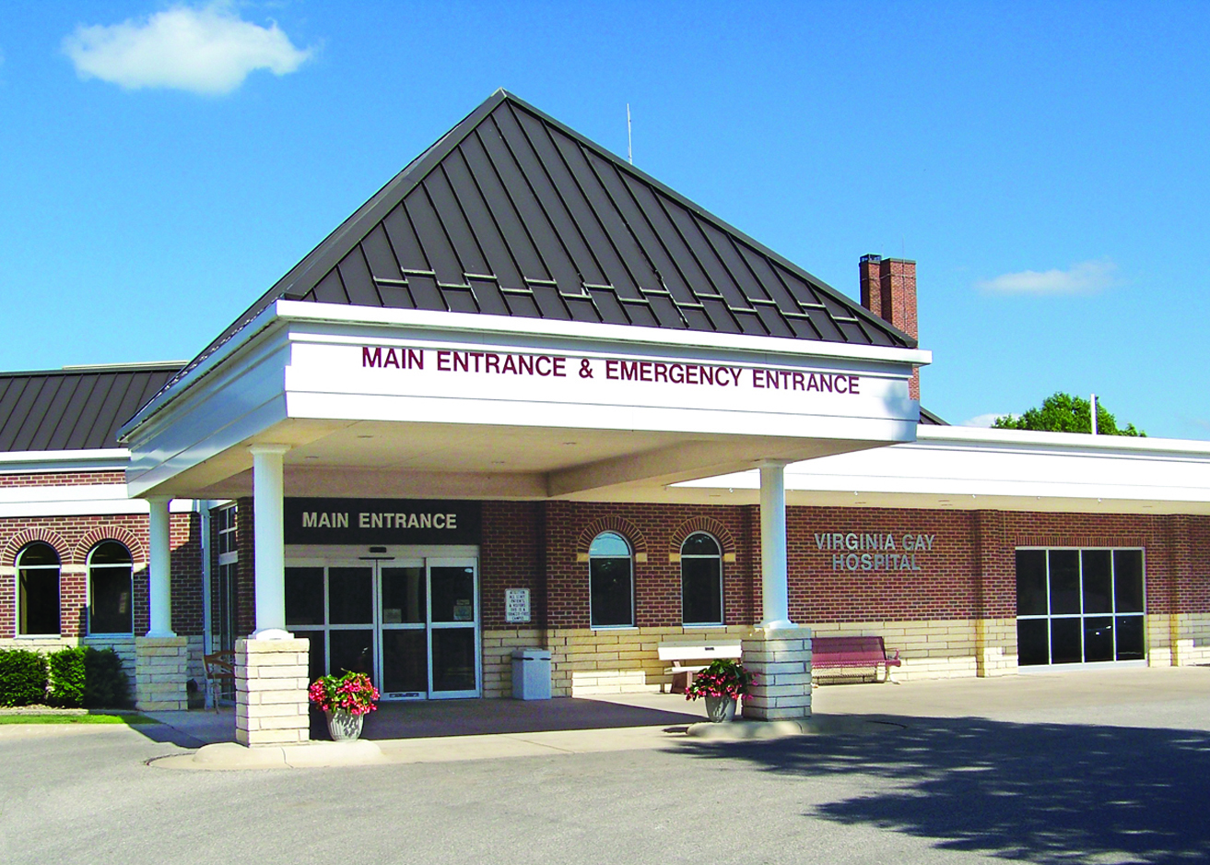

Community Health Needs Assessment (CHNA) 2025
Katie Cox
Virginia Gay Hospital
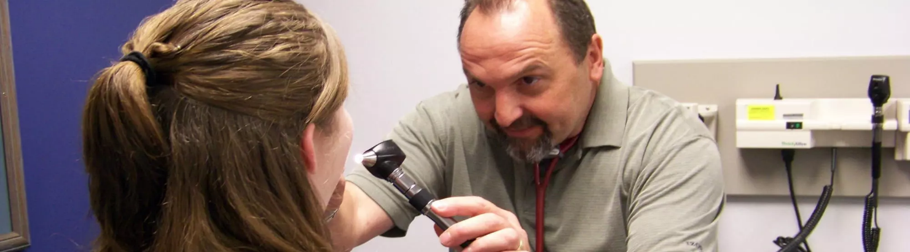

Table of Contents

About Virginia Gay Hospital…………………………..…..……...2
Purpose and Process of the CHNA………………………….…..4
Summary of the 2022 CHNA……………………………..…..……6
Community Description & Benton County Snapshot…..… 8
Key Health Findings………………………………..…..……...…… 10
Our Mission…………………………………………..……..…………13
Survey Instrument: Summary……………………….……..…….14
Health Priorities………………..………………..…….……………..19
Why These Priorities Matter – A Community Investment..20
Supporting Focus Ares...................................................21
Conclusion & Next Steps............................................... 21
Looking Ahead: Our Commitment to Action....................22
Appendix: Benton County Service Directory, Reference.…23

About Virginia Gay Hospital
Virginia Gay Hospital (VGH) has proudly served as Benton County’s only hospital since 1923, delivering high-quality, compassionate care to generations of families. Our origins trace back to a generous donation from Virginia Walcutt-Gay in 1914, and for more than a century, VGH has remained a cornerstone of health and healing for the greater Benton County area.
VGH continues to evolve with the support of our community, enabling the expansion of facilities, services, and outreach. In addition to our hospital in Vinton, we operate family medical clinics in Atkins, Van Horne, Urbana, and Vinton to extend access to care throughout rural Iowa.
As part of our dedication to community health, VGH conducts a Community Health Needs Assessment (CHNA) every three years. The CHNA identifies local health concerns and guides planning efforts to better meet the needs of residents.
Virginia Gay’s integrated healthcare organization includes:
- Three part-time family practice physicians
- Four family medicine advanced registered nurse practitioners (ARNPs)
- Three psychiatric mental health nurse practitioners (PMHNPs)
- Five physician assistants (PAs)
- Four hospitalists
- A broad range of clinical, support, and administrative staff
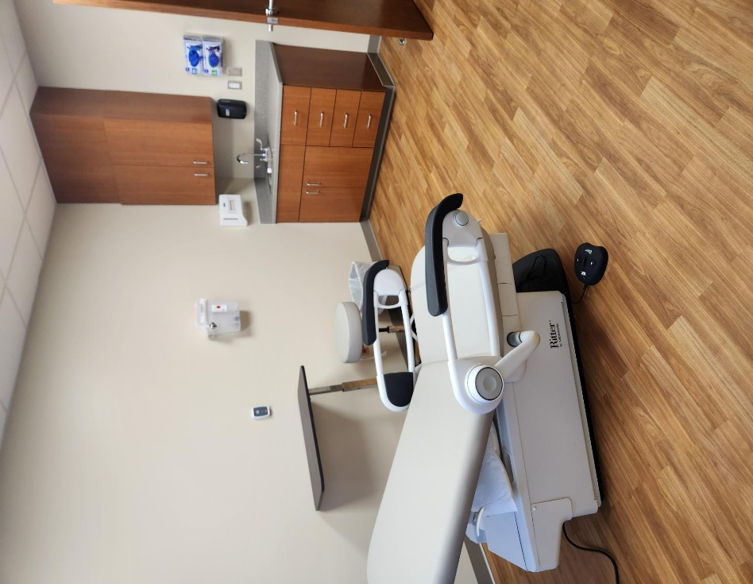
Through partnerships with specialists, we also provide surgical and specialty services on-site, including:
- Cardiology
- Dermatology
- Diabetes Education
- Endoscopy
- ENT (Ear, Nose & Throat)
- General Surgery
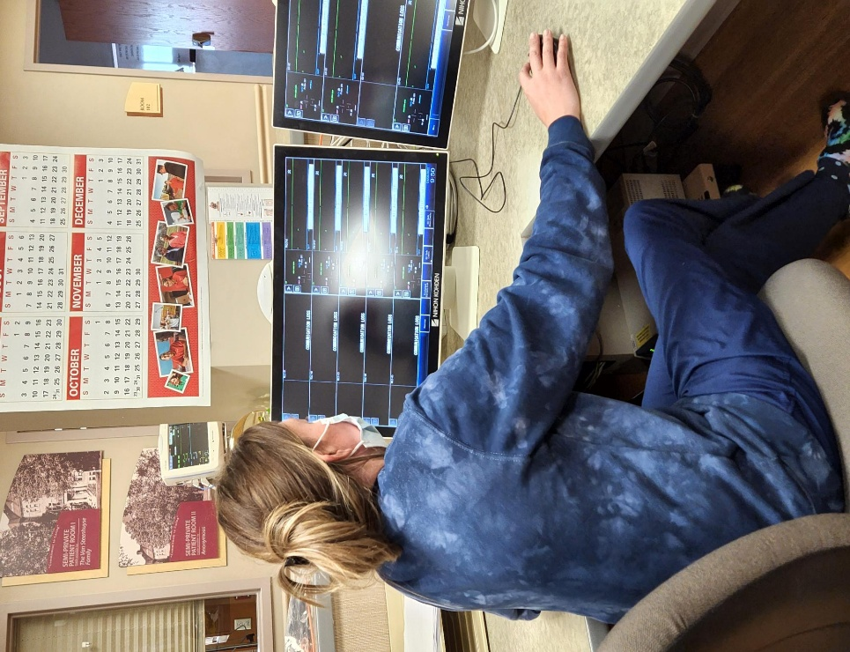
- Hematology/Oncology
- Nephrology
- OB/GYN (Women’s Health)
- Orthopedics
- Pain Management
- Podiatry
- Pulmonology
- Urology
- Wound Care
We offer a wide array of services designed to meet the evolving needs of our community, including:
- Acute inpatient and outpatient care
- Skilled nursing and long-term care
- Behavioral health services (ages 5+)
- Home health care and support for aging in place
- Imaging services (MRI, CT, ultrasound, mammography, X-rays)
- Laboratory testing (wellness panels, medication monitoring, pediatric screenings)
- Respiratory therapy and sleep studies
- Prenatal care through 30 weeks gestation
- Medical nutrition therapy and counseling
- Surgical services include a new state-of-the-art surgical suite.
- Well-child visits and preventive screenings
From emergency and acute care to wellness programs and chronic disease management, Virginia Gay Hospital is committed to improving the health and quality of life for every generation. With your continued support, we look forward to building on our legacy and shaping the next one hundred years of rural healthcare excellence. For more information about our services, please visit myvgh.org.
Purpose and Process of the CHNA
The Community Health Needs Assessment (CHNA) is a vital tool for identifying local health challenges, gaps in care, and opportunities for improvement. Informed by community feedback, county-level data, and health system expertise, it guides decisions about program development, service delivery, and resource allocation.
Survey Overview
An anonymous, 27-question survey was launched on May 21, 2025, to capture public input on personal and community health issues. A total of 143 responses were collected. The survey data was reviewed alongside public health statistics, healthcare access information, and service utilization trends to form a comprehensive view of health needs across Benton County.
CHNA Framework
Virginia Gay Hospital facilitated the CHNA process using the Healthy People 2020 MAP-IT framework, which is designed to guide public health planning and intervention. This framework helped mobilize partners, assess the needs and assets of our community, create and implement a strategic plan, and track progress toward identified health goals. While VGH led this initiative, multiple community partners were involved throughout the process.
- Mobilize: Brought together a diverse coalition of stakeholders committed to creating a healthier Benton County. Roles were clearly defined, and responsibilities were shared across sectors.
- Assess: Evaluated both community needs and available resources. Local and state data helped define a realistic baseline and allowed the coalition to prioritize needs based on feasibility, effectiveness, and impact.
- Plan: Identified SMART (Specific, Measurable, Attainable, Realistic, Timely) objectives and outlined actionable steps and measurable outcomes aligned with community priorities.
- Implement: Developed a detailed work plan that assigned clear responsibilities, set timelines, and established a communication strategy to ensure accountability and coordination.
- Track: Established regular evaluation benchmarks to monitor progress and maintain transparency by sharing outcomes and successes with the broader community.

Taskforce Members
Virginia Gay Hospital remains committed to fostering meaningful partnerships with organizations across Benton County. These collaborations are essential to improving health outcomes and strengthening local planning efforts.
To lead the CHNA process, Katie Cox, RN, BSN, Director of Ancillary Services and Community Health, coordinated data collection, conducted stakeholder interviews, and compiled findings for prioritization and planning.
Input & Health Needs Identified
A strategic planning session for Fiscal Year 2026 was held on March 14, 2025, bringing together VGH senior leadership, members of the Board of Directors, and medical providers to identify health priorities and set future goals. Senior management continues to meet twice monthly, with the most recent meeting on July 7, 2025, to review service area needs and drive responsive action.
In addition to internal efforts, VGH gathered input from external stakeholders representing both public and private sectors. These stakeholders were asked to identify the most pressing health concerns within the populations they serve. A common theme across responses was the impact of social determinants of health and health equity.
Public Health Focus Areas
To assess and prioritize local health needs, the CHNA process considered key public health functions that align with both community well-being and Virginia Gay Hospital’s mission. These include:
- Promoting healthy lifestyles through preventive care, screenings, and education
- Preventing injuries and disease via clinical services, vaccinations, and community partnerships
- Ensuring environmental and public safety in collaboration with local agencies
- Preparing for and responding to emergencies through hospital readiness and coordination with emergency services
- Strengthening health infrastructure and access by expanding local services and supporting care for vulnerable populations
These focus areas helped guide discussions, shape community engagement, and align priorities with statewide health improvement objectives and hospital goals.
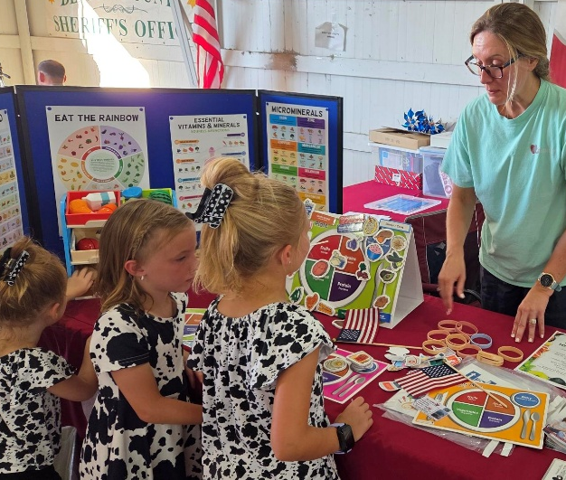
Community Engagement & Partners
VGH actively engaged a broad range of community partners from Fall 2023 to Spring 2025 to ensure diverse input—especially from those serving vulnerable populations. Outreach included surveys, interviews, emails, and meetings.
Participants included representatives from:
- Virginia Gay Hospital (hospital, clinics, home health, nursing & rehab)
- Benton County Government & Public Health (Board of Supervisors, Board of Health, Public Health, Environmental Health, Social Services, DHS, Emergency Management)
- Education & Youth Services (School districts, Better Tomorrows, Iowa State Extension Office)
- Community Coalitions & Nonprofits (Above the Influence, Disaster Recovery, Substance Abuse Coalitions, HACAP, ASAC)
- Law Enforcement, Transportation, and Recreation (local police, transportation providers, Vinton Parks & Rec)
- Mental Health & Emergency Preparedness (Abbe Center, Benton County Schools, Benton County Disaster Relief Coalition, Benton County Suicide Prevention Coalition, Vinton Public Library)
- Economic & Community Development (Vinton Unlimited, Benton County Development Group)
This collective input informed the identification of priority needs and reinforced the importance of ongoing collaboration.
Summary of the 2022 CHNA
In the 2022 CHNA, key priorities identified included mental health access, substance use prevention, and chronic disease management—particularly obesity and cancer. Residents also cited challenges related to transportation, affordability of care, and provider availability.
In addition to health-specific concerns, the assessment highlighted several social determinants of health, including the need for affordable housing, accessible childcare, and greater support for economic stability through job opportunities and workforce development. Gaps in emergency medical services and the need for improved transportation infrastructure were also emphasized as critical factors impacting timely access to care.
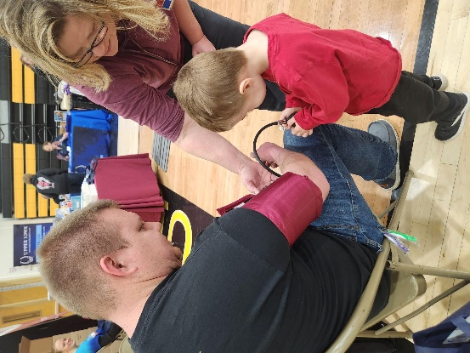
Equity and community inclusion emerged as foundational themes, with residents expressing the importance of inclusive, culturally aware healthcare access, as well as stronger outreach to underserved populations. Preventive health measures—such as improved nutrition education and chronic disease prevention—were seen as key to improving long-term community wellness.

In response, VGH implemented several targeted initiatives, including:
• Expanded access to mental health services through psychiatric nurse practitioner support and therapy referrals.
• Promoted substance misuse awareness through a community-wide opioid prevention campaign and secured funding from the Benton County Opioid Taskforce Grant to launch a Suboxone Outpatient Clinic. The clinic has been approved and is in the early stages of development, with services anticipated to begin later this year.
• Increased access to cancer screenings through "Ladies Night Out" mammogram events and mobile outreach.
• Enhanced nutrition and diabetes education with certified dietitian-led individualized support.
• Participated in the Benton County Wellness Coalition to support coordinated community health efforts.
• Hosted the VGH Health Fair—a large-scale event in collaboration with multiple local organizations that provided health screenings, education, and resources to the community.
- Partnered with HACAP to implement the Feeding America Program beginning in October 2022. Through this partnership, VGH worked to identify individuals and families experiencing food insecurity and connect them with a nonperishable food box distribution on site. The initiative also incorporates referrals to other community support services, helping address root causes of food insecurity.
- Established a SHIIP (Senior Health Insurance Information Program) partnership in August 2022. This collaboration has helped guide older adults through Medicare-related questions, plan comparisons, and enrollment decisions. The SHIIP clinic, coordinated by trained volunteers and VGH staff, served approximately 300 Benton County residents in its first year. To further increase community awareness, VGH hosted an informational SHIIP seminar in April 2023, offering valuable insights into Medicare benefits and helping residents make informed decisions about their healthcare coverage.
These and other efforts have worked to improve care access, promote preventive health, and strengthen community partnerships. The 2025 CHNA builds on these efforts, evaluates progress, and identifies new or persistent health challenges for continued action.
Community Description
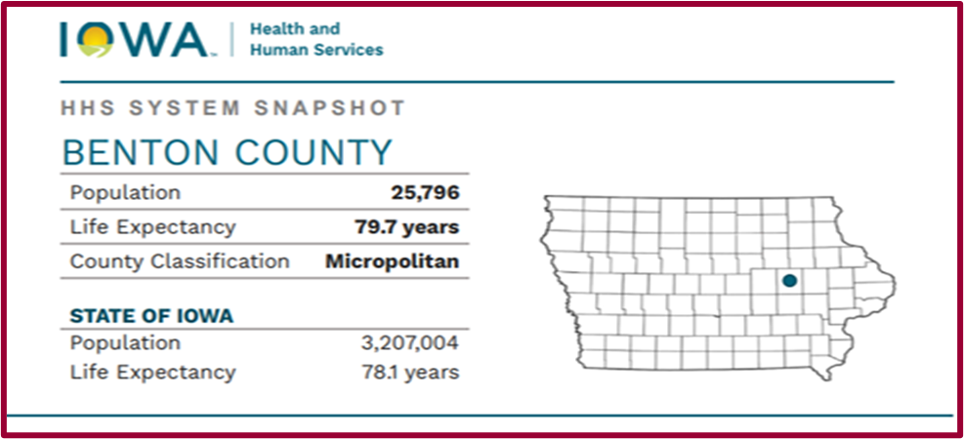
Primary Service Area (Benton County, IA)
Virginia Gay Hospital and Clinics (VGH) defines Benton County, with its 25,796 residents, as its primary service area. The county covers 716.27 square miles, ranking as the 25th largest in Iowa. The population has grown modestly by approximately 0.08% over the past year.
Utilization Patterns
According to the Iowa Hospital Association Dimensions Program in 2024, 81% of VGH’s 26,493 outpatient visits and 79% of its 330 inpatient discharges came from Benton County residents—underscoring the hospital’s integral role in serving local needs.
Life Expectancy Trends
Understanding national life expectancy trends helps contextualize local health challenges:
- For the U.S. population in 2023, average life expectancy was 78.4 years—a rise of 0.9 years from 77.5 years in 2022.
  - Men: 75.8 years (up from 74.8 in 2022)
  - Women: 81.1 years (up from 80.2 in 2022).
These gains stem largely from reduced mortality due to COVID-19, heart disease, cancer, unintentional injuries, and diabetes. However, U.S. life expectancy remains below the 2019 peak of 78.9 years and continues to trail other high-income nations.
Beyond Clinical Care
While quality, affordable healthcare is vital, broader socioeconomic factors—such as access to nutritious food, stable housing, education, economic opportunity, and transportation—play an even more influential role in determining health outcomes and longevity.
VGH is committed to addressing these upstream factors by partnering with community organizations, local schools, and governmental agencies to support health equity, preventative care, and population wellness initiatives across Benton County and surrounding service areas.
Benton County Snapshot
- Life Expectancy: 79.7 years (higher than Iowa’s 78.1)
- Poverty Rate: 8.3% (vs. 11.1% statewide)
- Medicaid Enrollees: 4,438
- Obesity Rate: 41.7% (vs. 37.3% statewide)
- Food Insecurity: Estimated 2,440 residents affected.

Key Health Findings
Access to Care
Benton County is designated as a Health Professional Shortage Area for primary care. Transportation challenges, cost of care, and insurance coverage issues contribute to access barriers. Telehealth and extended clinic hours are potential solutions.

Mental Health
- Poor Mental Health Days: 4.6 per month (above state average)
- Common concerns: stress, anxiety, depression, lack of providers
- Services: VGH provides therapy referrals and psychiatric nurse practitioner access
Substance Use
- Excessive Drinking: 25.5% (vs. 23.3% state average)
- Substance Use Treatment in 2024: 81 residents.
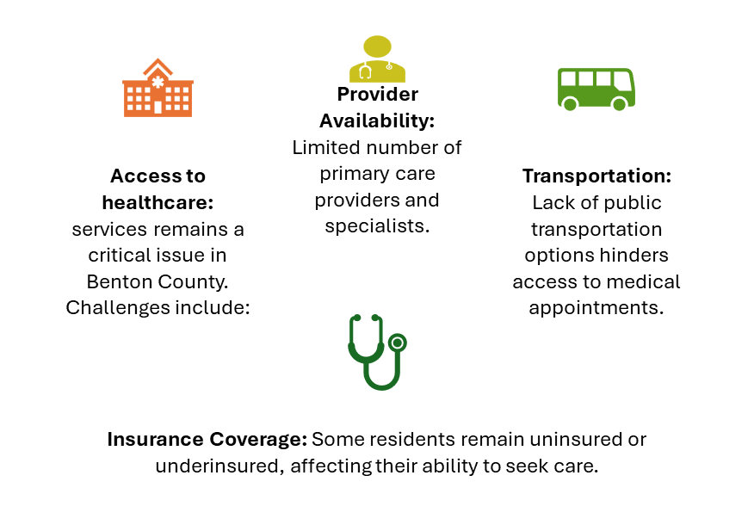
- Alcohol is the most commonly misused substance, followed by opioids and methamphetamines.
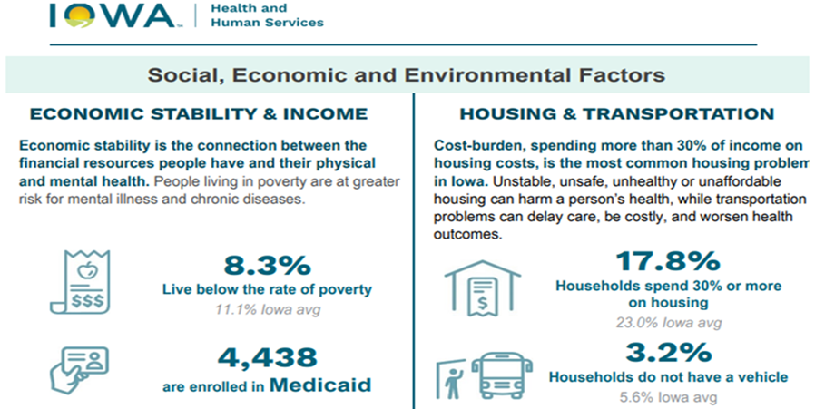
Nutrition & Physical Activity
- Obesity affects over 40% of adults.
- 17.8% of households spend over 30% of their income on housing.
- 3.2% of households lack access to a vehicle.
Environmental Health Concerns
Environmental factors affect community health:
- Air and Water Quality: Exposure to pollutants can lead to respiratory and other health problems.
- Agricultural Chemicals: Use of pesticides and fertilizers may impact human health.
- Climate Change: Increased frequency of extreme weather events poses health risks.
Cancer Rates
- Incidence: 513.6 per 100,000 (vs. 491.8 statewide)
- Death Rate: 141.4 per 100,000 (slightly better than state average)
- Screening and early detection are areas for increased outreach.

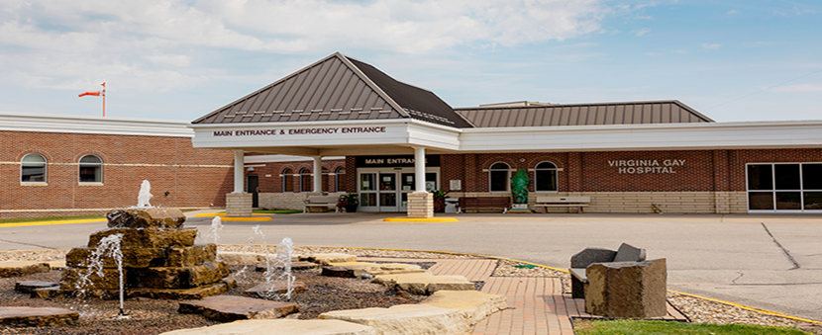
Pediatric Health Crisis
Children's health is a growing concern:
- Chronic Conditions: Increase in childhood obesity and related health issues.
- Mental Health: Rising rates of anxiety, depression, and behavioral disorders among youth.
- Nutrition: High consumption of ultra-processed foods contributes to poor health outcomes.
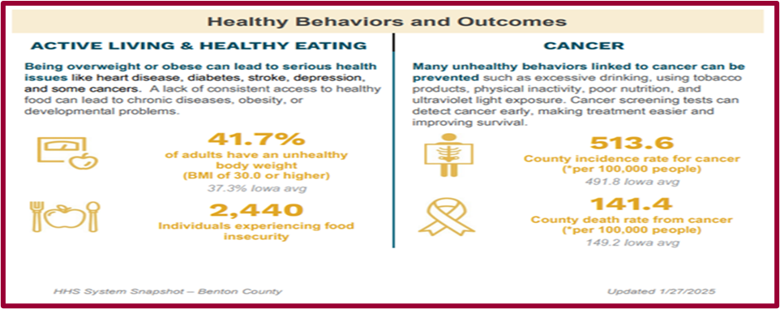

These statistics highlight areas where health interventions can be most impactful.
- Families with All Parents Working (Children <6): 79%
- Adults with Unhealthy Body Weight (BMI ≥30): 41.7% (Iowa average: 37.3%)
- Cancer Incidence Rate: 513.6 per 100,000 people (Iowa average: 491.8)
- Individuals Experiencing Food Insecurity: 2,440
Our Mission: A Healing Tradition
At Virginia Gay Hospital and Clinics, our mission is to improve the health and well-being of the individuals, families, and communities we serve by delivering compassionate, high-quality care. We are committed to excellence in every aspect of our work—striving not only to meet, but to exceed the expectations of our patients and community.
We believe healthcare should be accessible, affordable, and centered around the unique needs of each person. That is why we aim to provide services that are not only clinically effective, but also convenient, respectful, and grounded in genuine human connection. Our goal is to set the standard for rural healthcare by fostering innovation, supporting wellness at every stage of life, and ensuring that every patient experience reflects our core values of integrity, compassion, accountability, and continuous improvement.
The priorities identified through the CHNA process—such as improving access to care, addressing mental health and substance use, and supporting vulnerable populations—directly reflect Virginia Gay Hospital’s mission and values. By upholding our commitment to compassion, competence, and collaboration, we are developing action plans that strengthen preventive services, expand rural access, and build meaningful partnerships. Each strategy is designed not only to address immediate health concerns but also to support long-term community well-being, consistent with our vision of being the best place to receive care and a trusted leader in rural health.
Through dedicated teamwork, community partnerships, and a focus on long-term impact, we work to build a healthier future for Benton County and beyond.

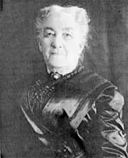
I have an affection for Vinton and its people because most of the years of my life were spent in it and among its people. They were my happiest years. For these reasons, I have made this provision for a hospital in Vinton. It shall be known and designated as the Virginia Gay Hospital.” ~ Virginia Gay

Survey Instrument: Summary
Overview
To assess the health needs and experiences of Benton County residents, a community survey was conducted. The questions covered demographics, access to care, health behaviors, mental wellness, and community perceptions. The findings offer insight into both strengths and opportunities for improving local health systems and services.
Demographics
ZIP Code Most participants live in ZIP code 52349, which includes Vinton—the core service area for Virginia Gay Hospital (VGH). A smaller number came from surrounding Benton County towns or neighboring areas, showing both local loyalty and regional outreach.
Age Survey respondents skewed older, with nearly 70% age 45 or older. The most common age groups were 65–74 and 55–64. Young adults under twenty-five represented a small segment, suggesting that older adults are either more engaged with community health issues or more likely to complete health surveys.
Gender The survey population was predominantly female, making up more than four-fifths of responses. Males accounted for about one-sixth, and a small number of individuals declined to report their gender. This may reflect both community demographics and the likelihood of women seeking or engaging with health services.
Race/Ethnicity The community remains largely racially homogenous, with nearly all respondents identifying as White. Only one participant identified as Asian, and no other racial or ethnic groups were represented in the survey, which aligns with Benton County's demographic profile.
Education Respondents demonstrated a well-educated population. Most had education beyond high school, with strong representation among those holding associate, bachelor’s, or graduate degrees. No one reported less than a high school education, reflecting a community with overall strong educational attainment.
Employment Status Half of all respondents were working full-time, and about one-third were retired. Part-time workers, the self-employed, students, and homemakers made up the remainder. Notably, no respondents reported being unemployed, which may point to relative economic stability within the group surveyed.
Household Income Most respondents reported middle-income earnings, with over half making under $75,000 per year. The largest single income group earned between $25,000 and $49,999. Only a small portion fell below $25,000 annually, suggesting fewer respondents from the lowest-income brackets.
Health Insurance Coverage The vast majority of respondents had some form of health insurance, most commonly through an employer. Medicare and Medicaid were also widely used. A few had private, non-employed plans or mixed coverage (e.g., Medicare with a supplement). Importantly, no respondents reported being uninsured—an encouraging sign of healthcare accessibility.
Length of Residency in Benton County The survey reflects a deeply rooted community, with more than 80% of respondents having lived in Benton County for over a decade. Only a small portion had recently moved in or lived outside the county, indicating that long-term residents were the primary voices captured.

Access to Care
Primary Care Access
Nearly all respondents reported having a regular primary care provider, suggesting that basic access to routine and preventive care is well established in Benton County.
Where Care is Sought
Most community members seek medical advice or treatment at local clinics. Only a few reported using urgent care or telehealth, and no one identified the emergency room as their first choice for care. This suggests that residents are generally accessing care at appropriate levels.
Barriers to Accessing Care
While nearly half of all respondents reported no barriers, others cited difficulties such as limited appointment availability and cost concerns. A few mentioned delays in scheduling or poor communication with certain departments, but no one reported issues with transportation or language access.
Delays in Seeking Care
Although only a small percentage formally stated they had delayed or avoided care, open-ended responses revealed that many had faced delays due to costs, time constraints, or limited appointment availability. Others noted frustrations with provider communication or system navigation.
Ease of Getting Appointments
While a majority found it easy to book appointments, a huge portion still experienced challenges—particularly in getting timely or urgent care. This suggests a need for improved scheduling systems and potentially expanded hours or staffing.

Lifestyle & Wellness
Exercise Habits
Most residents reported exercising at least once per week, with many exercising multiple times weekly. However, nearly one in five were not engaging in any physical activity, indicating a need for continued promotion of active lifestyles.
Dietary Patterns
The majority described their diets as “somewhat healthy,” with only a small portion rating theirs as “very healthy.” A small group acknowledged poor dietary habits. These results show that while many residents are trying to eat well, there is room for improved nutrition, education, and support.
Tobacco Use
Tobacco use was low overall. A majority reported never using tobacco, and several others had quit. A small percentage were current users, suggesting that ongoing cessation resources could be helpful but not broadly required.
Sleep Habits
Most respondents reported getting between 6 and 7 hours of sleep per night—slightly below the recommended 8-hour standard. A smaller group was reaching the ideal range, while others were sleeping only 4–5 hours, potentially increasing risk for fatigue-related health issues.
Preventive Screenings
Engagement with preventive screenings was strong. Blood pressure, dental visits, cholesterol checks, and cancer screenings were common, although fewer reported being screened for diabetes. Only a small group reported not participating in any screenings.

Mental Health
Stress and Anxiety
Half of the respondents reported experiencing stress or anxiety either daily or weekly. This indicates a significant mental health burden within the community that may benefit from expanded services and awareness.
Use of Mental Health Services
Less than one-third of respondents had ever accessed mental health services, despite high rates of reported stress. This gap suggests a potential underutilization of available resources, possibly due to stigma, lack of awareness, or other barriers.
Awareness of Mental Health Resources
While two-thirds of participants said they would know where to go for mental health care, a sizable group (35%) either did not know or were unsure. This underscores a need for better communication about where and how to access help.
Community Feedback & Priority Needs
Desired Improvements at VGH
Residents most often asked for better access to providers, including more full-time doctors and improved scheduling options. Other top requests included expanded specialty services (e.g., neurology, endocrinology, mental health, women’s health) and urgent care availability.
Participants also expressed concern over continuity of care, citing provider turnover and a desire for improved retention. Communication challenges—such as unclear scheduling or lack of follow-up—were mentioned as well.
Suggestions extended to improving clinic and ER efficiency, food options, and the availability of diagnostic and preventive services. Many comments reflected appreciation for the care VGH already provides.
Most Pressing Health Issues
Mental health and substance use were the most commonly mentioned community concerns. Chronic conditions such as diabetes and heart disease were also frequently cited. Additionally, the health needs of older adults and access to wellness services for prevention were growing priorities.
Factors Affecting Well-being
Financial Stress was the most frequently reported issue negatively impacting health. Social isolation was also noted, particularly among older adults. Other concerns included food insecurity, housing instability, and limited transportation access. Overall, digital access was not seen as a barrier.
Access to Healthy Living Resources
Most respondents felt the community offered at least some of the resources needed to live a healthy life. However, many shared that services were not always well-publicized or easy to access. Mental health care, recreational spaces, nutrition education, and elder services were shared areas where residents saw gaps.
Additional Suggestions from Open-Ended Comments
- A need for grief and mental health support, especially for seniors.
- Requests for more primary care providers and clinic efficiency improvements.
- Expanded preventive care, including screenings and education.
- Strong desire for community spaces, including walking trails, pools, and fitness centers.

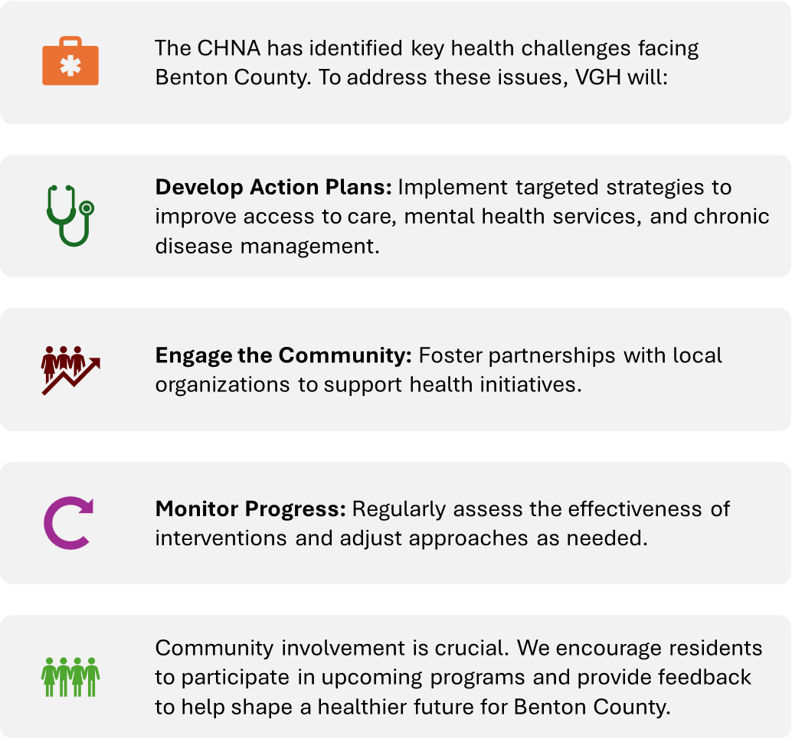

2025 Health Priorities
Virginia Gay Hospital remains steadfast in its mission to serve the health needs of Benton County through compassionate, evidence-based care that responds directly to the voices and experiences of the community. The 2025 Community Health Needs Assessment (CHNA) has been instrumental in identifying the most urgent and persistent health challenges facing our region today. Through survey data, public health trends, and community engagement, three top priorities have emerged: Mental Health, Substance Abuse and Treatment, and Chronic Conditions (including Cancer, Diabetes, and Heart Disease).
These priorities are more than just areas of concern—they are calls to action. They reflect the growing health disparities and service gaps that affect the well-being of individuals and families throughout our service area. For VGH, addressing these challenges is a fundamental part of our mission and a responsibility we share with public health agencies, local organizations, and community partners.
- Mental Health care has become a pressing concern, particularly in light of increased isolation, economic pressures, and provider shortages across rural Iowa. By focusing on mental health, VGH aims to reduce stigma, expand access to services, and strengthen early intervention and support systems—especially for youth, seniors, and underserved populations.
- Substance Abuse and Treatment remains a complex issue in Benton County, as the use of alcohol, opioids, and methamphetamines continues to impact individuals and families. VGH is committed to expanding treatment pathways and prevention programs, including the launch of a local Suboxone clinic in 2025, which will provide life-saving support for those struggling with opioid use disorder.
- Chronic Conditions like cancer, diabetes, and heart disease continue to be the leading causes of death and disability in our region. Through proactive outreach, screenings, patient education, and care coordination, VGH seeks to improve outcomes, promote early detection, and support healthy lifestyle changes that can prevent or manage these lifelong illnesses.
Investing in these health priorities strengthens the overall health of our community and improves quality of life for current and future generations. These initiatives also reflect VGH’s ongoing commitment to community-driven care—where local needs guide local solutions. By working collaboratively with residents, healthcare providers, schools, businesses, and civic leaders, we can build a healthier, more resilient Benton County.
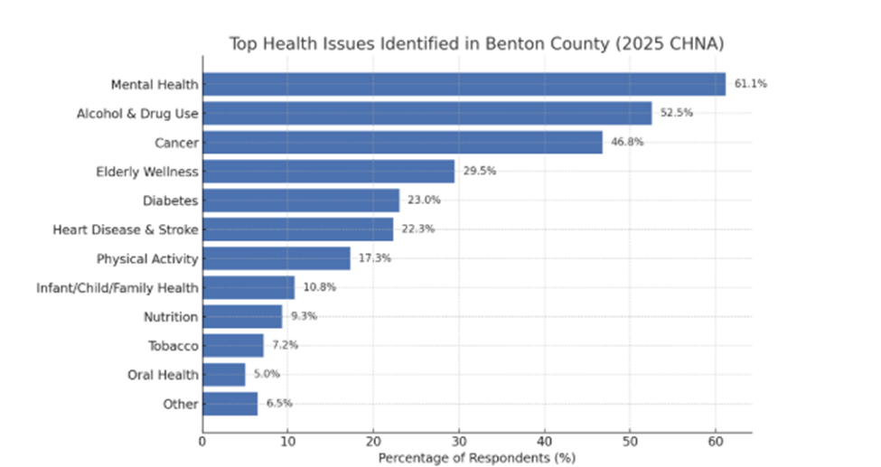

Why These Priorities Matter – A Community Investment
Addressing these areas is not just a healthcare initiative, it is a community-wide investment in a healthier, more resilient Benton County. VGH recognizes the unique challenges rural communities face, including provider shortages, transportation barriers, and stigma related to seeking care. By aligning our services with local needs, we strengthen the foundation for long-term wellness.
We are also committed to health equity, ensuring every resident—regardless of income, location, or background—has a fair opportunity to live a healthy life. Our approach includes:
- Partnerships with local organizations, schools, first responders, and Benton County Public Health.
- Data tracking and measurable outcomes to evaluate success and adapt programs as needed.
- Community voices guiding strategy through ongoing surveys, focus groups, stakeholder interviews, and outreach events.
“These initiatives reflect more than a response to statistics—they are about saving lives, restoring hope, and empowering our neighbors to thrive.” – VGH Leadership Team

Supporting Focus Areas
In addition to the top priorities, Virginia Gay Hospital will continue efforts in the following key areas, which align closely with and support the above goals:
• Access to Care
- Expand same-day and acute appointment availability.
- Recruit and retain medical providers and specialists.
- Improve scheduling and communication systems.
• Community Outreach & Health Literacy
- Increase public awareness of services and how to access them.
- Offer educational events, workshops, and printed materials in plain language.
- Promote equitable access to care across all demographics.
• Senior and Vulnerable Population Support
- Enhance access to elder care, home health, and transportation services.
- Address financial, housing, and isolation challenges affecting older adults.
- Strengthen partnerships to support daily living and caregiving resources.
These efforts will be reflected in shared strategies and aligned with broader health improvement goals.
Conclusion & Next Steps
This CHNA was officially adopted by the Virginia Gay Hospital Board of Directors on July 15, 2025. To guide continued progress, VGH will develop a Health Improvement Plan (HIP) using the MAP-IT framework (Mobilize, Assess, Plan, Implement, Track). The HIP will:
- Define measurable goals and action steps for each priority area.
- Integrate supporting focus areas into cross-sector strategies.
- Assign timelines and responsible stakeholders.
- Track outcomes and report progress to the public.

Looking Ahead: Our Commitment to Action
As we move forward, Virginia Gay Hospital will continue to take decisive steps toward improving community health outcomes. Our goals will be measurable, transparent, and community driven. We are proud to announce that we will:
- Collaborate closely with Benton County Public Health and regional partners to share resources, data, and innovative strategies.
- Expand targeted outreach through education campaigns, school-based initiatives, screenings, and preventive care programs.
- Ensure transparency and accountability by publicly sharing CHNA findings, implementation plans, and progress updates with the community.
We are deeply grateful to all residents, employees, and community partners who contributed their insights, experiences, and ideas throughout this process. Your voice has shaped a strategic path forward.
Together, we are not just responding to health challenges—we are building a healthier, more connected, and more resilient Benton County for future generations.
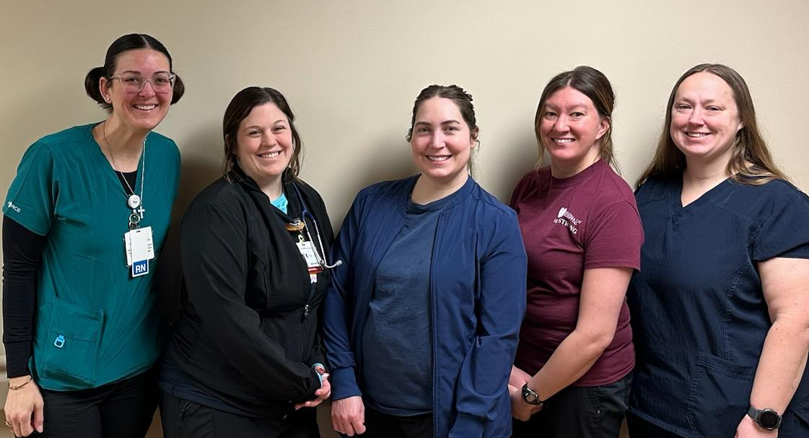
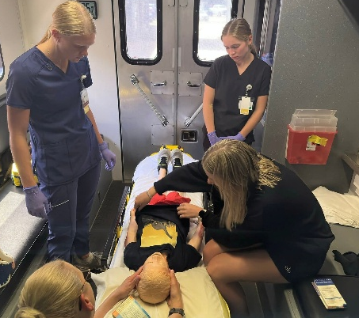
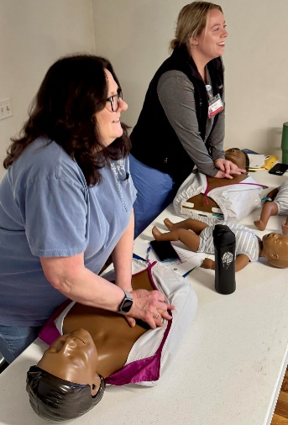

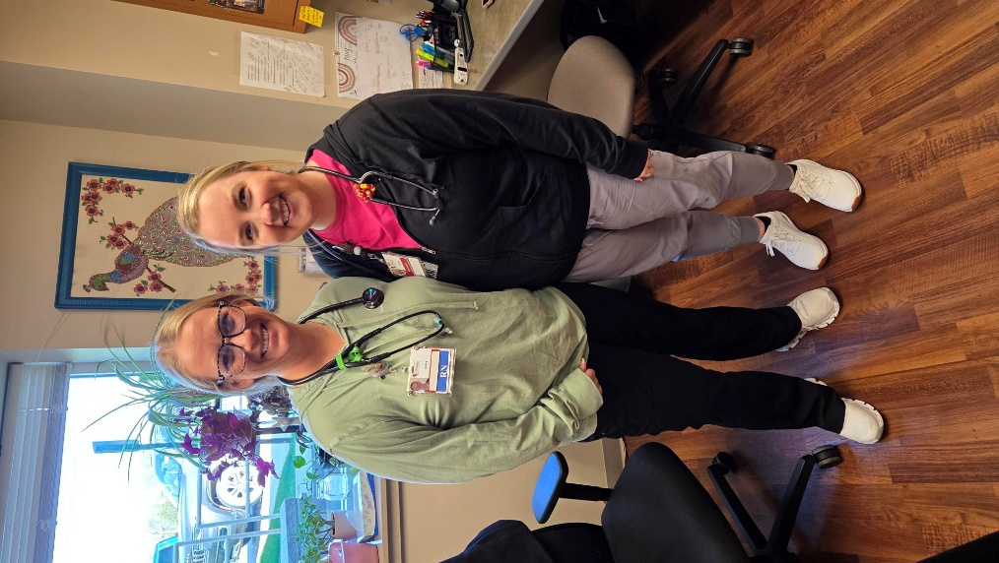
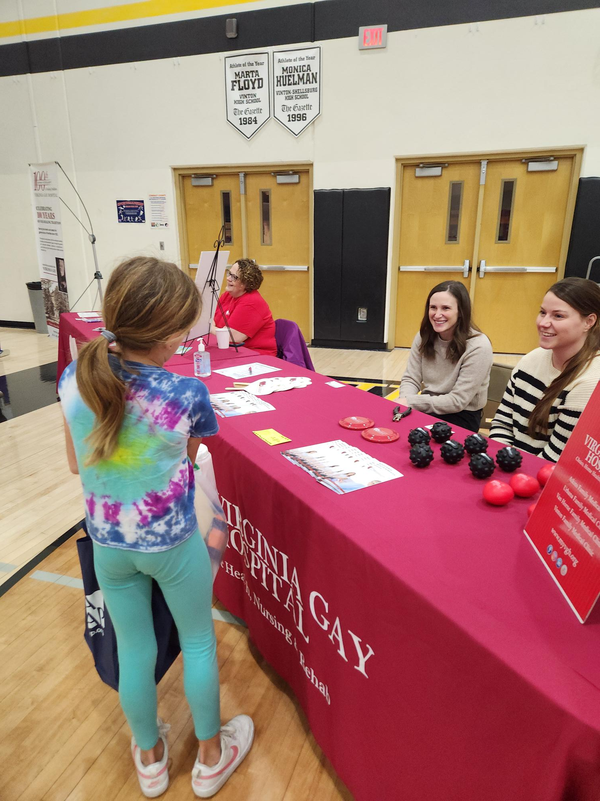
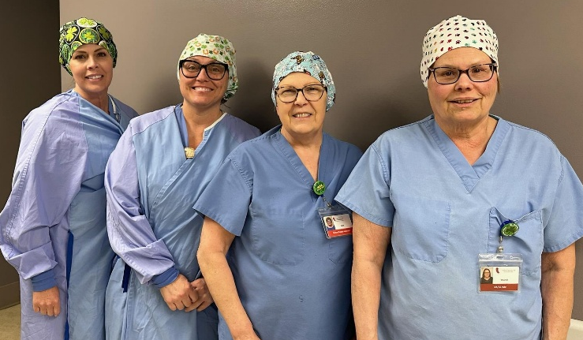

Appendix
Benton County Resource Directory: https://www.bentoncountyia.gov/files/social_services/benton_county_resource_directory_41239.pdf
References:
- Iowa Hospital Association. (2025). Dimensions Program Utilization Data. Retrieved from https://www.ihaonline.org
- Centers for Disease Control and Prevention (CDC). (2024). National Center for Health Statistics – Life Expectancy Tables. Retrieved from https://www.cdc.gov/nchs
- National Academies of Sciences, Engineering, and Medicine. (2024). Understanding U.S. Life Expectancy Trends. Retrieved from https://nap.nationalacademies.org
- Wikipedia. (2024). Life Expectancy in the United States. Retrieved from https://en.wikipedia.org/wiki/Life_expectancy_in_the_United_States
- Time Magazine. (2024). Why U.S. Life Expectancy Still Trails Other Developed Nations. Retrieved from https://time.com
- Vox Media. (2024). Health Disparities and Global Life Expectancy Comparisons. Retrieved from https://www.vox.com
- Associated Press (AP News). (2024). U.S. Life Expectancy Rebounds, But Still Below Pre-Pandemic Levels. Retrieved from https://apnews.com
- County Health Rankings & Roadmaps. (2024). Benton County Health Data. University of Wisconsin Population Health Institute. Retrieved from https://www.countyhealthrankings.org
- Iowa Department of Public Health (IDPH). (2024). Iowa Health Improvement Plan: 2023–2025. Retrieved from https://idph.iowa.gov
- Healthy People 2020 Framework. (2020). MAP-IT: A Guide to Health Improvement Planning. Office of Disease Prevention and Health Promotion. Retrieved from https://www.healthypeople.gov
- Mental Health America. (2024). The State of Mental Health in America 2024. Retrieved from https://mhanational.org
- Substance Abuse and Mental Health Services Administration (SAMHSA). (2024). Behavioral Health Barometer: Iowa, Volume 7. Retrieved from https://www.samhsa.gov
- Iowa Department of Human Services. (2024). Iowa Opioid Response Annual Report. Retrieved from https://dhs.iowa.gov

